**Hokkaido University Top Collaboration Program**

**Dublin Institute of Technology (DIT) and Hokkaido University (HU)**

**Ireland - Japan Energy Seminars**

**23rd March, 2015 13:00～18:00**

**Frontier Research in Applied Sciences Building, Faculty of Engineering, Hokkaido University**

12.30 Registration and Coffee

13.00 Welcome address, Prof. Toyoharu Nawa, Dean of Faculty of Engineering, HU

13:05 Commemorative speech, Ms. Anne Barrington, Ambassador of Ireland to Japan

13:20 Key note lecture, Prof. Brian Norton, President of DIT

“Advances in solar thermal and photovoltaic devices”

14.05 Key note lecture, Prof. Katsunori Nagano, Presidential advisor of HU

“Developments of the Ground Source Heat Pump System in Japan”

14.35 Coffee Break

14.50 Dr. Marek Rebow, Head of Research, College of Engineering and Built Environment, DIT

“Research, Development & Demonstration at the Dublin Energy Lab DIT  
 with particular focus on thermal energy storage”

15.15 Prof. Tomohiro Akiyama, Head of Center for Advanced Research of Energy and Materials, HU

“Questing for Innovative Energy Media Materials”

15.40 Prof. Ryuzo Ohoka, Institute of Industrial Science, the University of Tokyo

“Present Situation of the Net Zero Energy Building in Japan”

16.05 Mr. Hirose, Director, Heat Pump Technology Centre of Japan (HPTCJ)

“Recent situation of heat pump and thermal energy storage in Japan” (Tentative)

16:30 Prof. Takemi Chikahisa, Dean of Faculty of Engineering, HU

“Distributed energy system for the smart community” (Tentative)

16:55 Assoc. Prof. Taro Mori, Division of Human Environmental System, HU

“New methodology for analysis of urban thermal environment using GIS data”

16.15 Mr. Philippe Lemarchand, PhD student, DIT

“Integration of smart and intelligent technologies for energy efficient building”

17:35 Mr. Hiroto Katayama, Manager, Dimplex Japan Co. Ltd., Glen Dimplex Group

“Global renewable energy strategies of Glen Dimplex group” (Tentative)

17.55 Closing address, President Norton, DIT/ Prof. Nagano, HU

**Map**

**The 2nd floor, Lecture hall**

**Frontier Research in Applied Sciences Building, Faculty of Engineering, Hokkaido University**

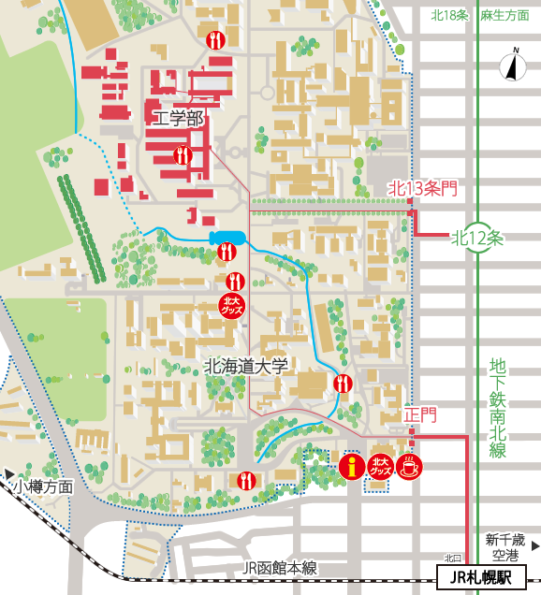

**JR Sapporo Station**

**Faculty of Engineering**

**Hokkaido University**

**Subway**

**Nan-boku line**

**University Gate**

**Kita 13 Jou Gate**

**Kita 12 Jou Subway Station**

N13-W8 Kita-ku, Sapporo 060-8628 Japan  
Faculty of Engineering/ Graduate School of Engineering, Hokkaido University