Hitachi Hokkaido University Laboratory and Hokkaido University to hold the “Math for Social Creativity Programming Contest 2019”
Accelerating the development of spatio-temporal optimization solvers for social innovation through industry-academia collaboration

Hitachi Hokkaido University Laboratory (Hitachi Hokudai Labo), established by Hitachi Ltd. on the premises of Hokkaido University, and Hokkaido University announce the jointly organized “Hitachi Hokudai Labo & Hokkaido University Contest 2019”.
Hitachi Hokudai Labo and its partners at Hokkaido University are currently undertaking major research efforts to develop novel solutions for emerging societal issues such as depopulation, declining birth rates, and an aging society in Hokkaido. Towards this goal, Hitachi Hokudai Labo has partnered with local governments to promote regional revitalization through pilot studies. In addition, we actively engage in research on novel spatio-temporal optimization technology which robustly adapts its solutions to sudden temporal changes. Ultimately, this research targets novel service proposals. For example, a shopping support system that searches for adaptive routes in response to varying road conditions, a snow removal scheduler which allows for flexible, cost-saving adaptions to weather conditions, or a robustified power supply system which can compensate disaster induced power outages using local biomass energy production.
Towards its research goal Hitachi Hokudai Labo and Hokkaido University have established a wide-ranging industry-academia collaboration, fostering synergies from diverse disciplines such as information science, mathematics, and hardware architecture to promote research and development of next-generation optimization technology. Supported by the expertise of this network, Hitachi Hokudai Labo and Hokkaido University designed this year’s contest on spatio-temporal optimization, continuing a longstanding strive to promote research through open innovation as documented by previous marathon-type programming contests in 2017 and 2018.
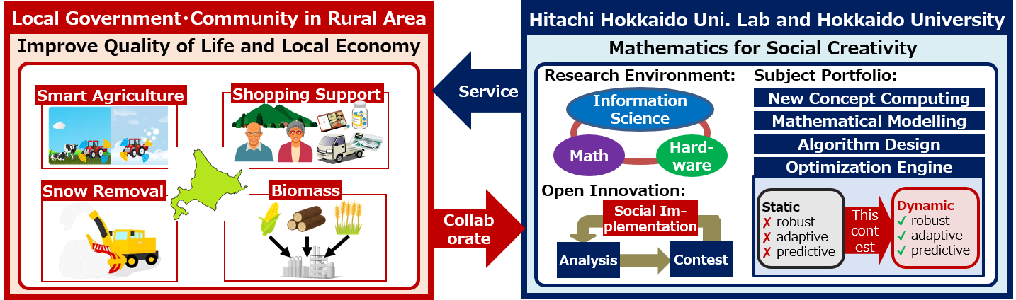
Fig1: Hitachi Hokudai Labo’s mission to developing novel services with local governments based on math for social creativity
To ensure maximal fun with the creation of novel algorithms this year’s contest has again been designed and implemented in close collaboration with the students of Hokkaido Universities Programming club. The contest itself will be carried out on the AtCoder cloud system, providing access to an international community of programmers who offer a healthy and friendly competition. Finally, the contest provides a field for innovation, granting the best ranking contestants a chance to present their algorithm and ideas to an expert audience at the national convention of the information processing society of Japan (IPSJ).
Participants of this contest can register online and submit an answer code at any time during the event. The submitted answer codes are immediately executed and scored online by the automatic scoring program, and the current ranking is displayed. In this way, participants can improve their answer codes iteratively. In addition, participants can submit answer codes any number of times they like regardless of location and time, making the contest suitable for beginners. In fact, past contests have received over 300 answer codes from a wide range of participants, including high school students and adults, devising algorithms which outperformed the state of the art in computer science.
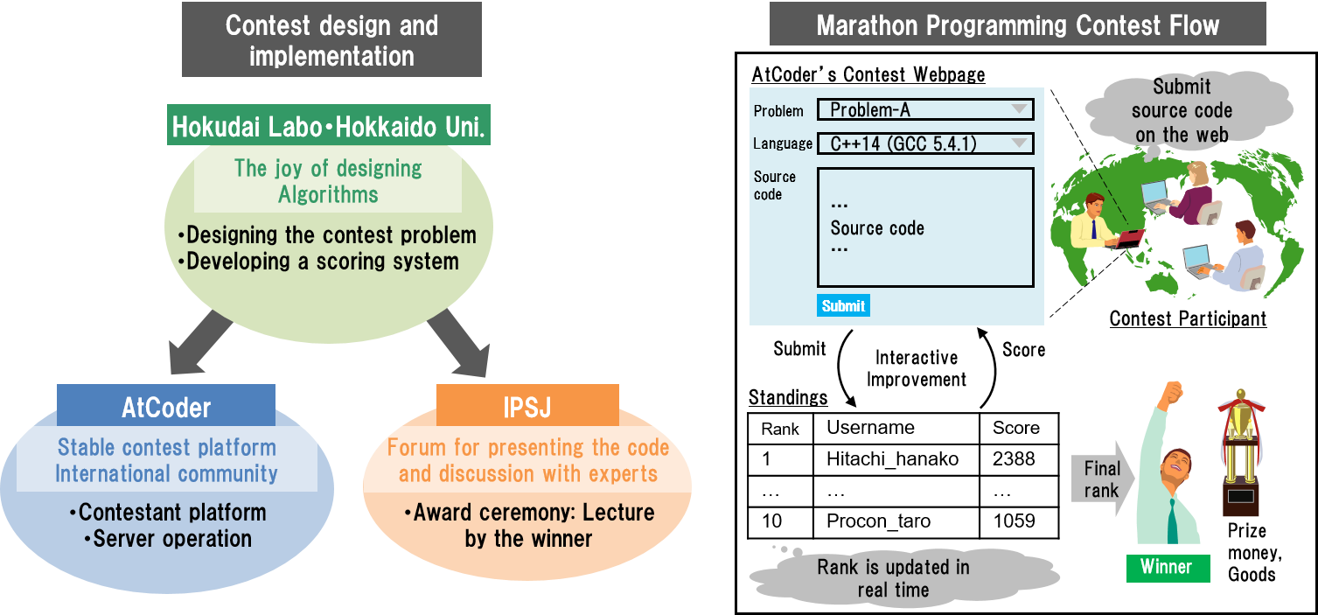
Fig 2: Hitachi Hokudai Labo and Hokkaido University joint programming contest

In this year’s contest we will prepare three problem statements (A, B, and C) on the topic of spatio-temporal optimization.

■ Schedule
1st contest: November 8th 2019 ～ November 21st 2020 (Problem A and B)
2nd contest: November 29th 2019 ～ December 12th 2019 (Problem C)

The winners of contest A, B, and C will be awarded 100.000 JPY, 200.000 JPY, and 300.000 JPY, respectively. Moreover, we prepare special goods and further prize money for successful contestants. Finally, we will organize an award ceremony at the 82th National Convention of the Information Processing Society of Japan, where the contest winners will be invited to present their algorithms.

■ Date：March 6th 2020, 11:40 am – 12:30 pm
■ Place：Kanazawa Institute of Technology, Ougigaoka Campus, Building 8, Room 104

The programming contest is open to everybody, regardless of age, nationality, and gender and everyone interested in participating in the contest is cordially invited to join through the following websites.

1st contest: https://atcoder.jp/contests/hokudai-hitachi2019-1
2nd contest: https://atcoder.jp/contests/hokudai-hitachi2019-2

*A marathon-type programming contest is an event in which submissions can be made for several days. This year both contests will be open for a submission period of 14 days.

